Are You Going to be Solid Red?

Purchase this t-shirt to join in our SOLID RED campaign for 8th Grade Day!

Deadline for purchasing T-shirts: Friday May 17, 2013

Back
Front

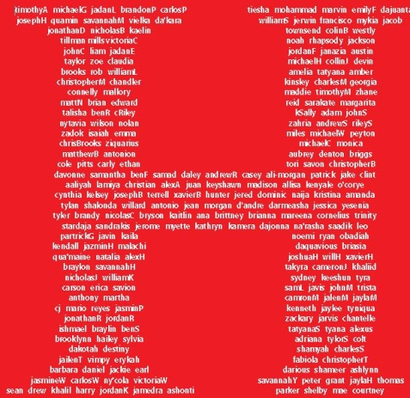


*T-shirt will be red with white font.

Price: $10.00

8th Grade Day T-shirt Order Form
All orders with money must be turned in to Mrs. Clarke in the morning.
Room 604
Name:
Homeroom Teacher:
Number of Shirts/Sizes:
Shirt Sizes: (please circle the size(s) you are ordering)

S M L XL 2XL 3XL 4XL

Total Amount Paid:

*Add $1.00 to a 3XL and 4XL t-shirt

Only CASH will be accepted for payment.

